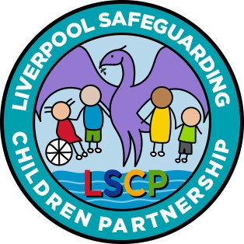

INFORMATION FOR PARENTS AND CARERS

Raising safeguarding concerns regarding professionals and volunteers who work with children and young people
www.liverpoolscp.org.uk

WHY AM I RECEIVING THIS LEAFLET?

You are receiving this leaflet as information has been received which alleges the child or young person you care for may have
been harmed by an adult working with children. A safeguarding allegation is not the same as a complaint about a service.

The majority of people who work with children or young people act professionally and aim to provide a safe and supportive
environment for them. However, sometimes the behaviour of
adults who work or volunteer with children and young people can result in allegations being made against them.

It is never acceptable for an adult in a position of trust to harm a
child or young person and therefore, allegations or concerns about behaviour raised about
paid staff or volunteers in relation to children or young people are taken seriously.

WHAT IS THE LOCAL AUTHORITY DESIGNATED OFFICER ROLE?

If somebody works with children within the City of Liverpool, the Local Authority Designated Officer will oversee allegations. The work can be unpaid or paid. A concern can be in relation to the person’s behaviour at work or outside of their workplace.

The decision to suspend an employee is the responsibility of the employer.

WHAT HAPPENS NEXT?

- Allegation reported to the Local Authority’s Designated Officer

- The Local Authority’s Designated Officer will consider whether a
discussion or meeting should be held to decide if further action is needed

- If it is necessary to investigate further a decision will be made whether this will be the Police, Children’s Social Care or the employer or a combination of agencies

- An appointed investigating officer may wish to meet with your child to discuss the allegation. This will be discussed with you beforehand

- Following the investigation, a decision will be made to record the outcome as: Substantiated, Unfounded, Unsubstantiated, Malicious or False

OUTCOME

At the end of an investigation an outcome is needed. The possible
outcome will be one of the following:

Substantiated Evidence was available to prove that what was alleged did happen.

Unsubstantiated It cannot be proven either way that the allegation did or did not happen

Unfounded Evidence was available to prove that what was alleged didn’t happen or couldn’t have happened or information has been misinterpreted.

False There is sufficient evidence to disprove the allegation

Malicious A deliberate act to deceive. For an allegation to be classified as malicious, it will be necessary to have evidence which proves the intention.

The outcome of any investigation is final. Detailed information regarding the full extent of the investigation may not be able to be shared with you further than action has been taken and appropriate safeguarding measures have been implemented.

This is due to data protection requirements and is not about withholding information from you. You can be assured that Liverpool Safeguarding Children Partnership provides independent scrutiny of all investigations.

PERSONAL SUPPORT

A named person will be identified to keep you informed throughout the process of any developments. You will be informed when the matter has been concluded.

This named person could be the
lead with the investigating agency, such as a social worker or police officer, or it could be a manager within the employing agency of the adult about whom concerns have been raised.

Further information about managing allegation procedures can be found on Liverpool Safeguarding Children Partnership website at:

www.liverpoolscp.org.uk

